# **How Much Does it Cost to Outsource Website Development**

Much of the modern business world takes place online. This makes web development extremely important to companies of all shapes and sizes. Web creation and management include a wide range of complex tasks. Taking this in-house can be time-consuming.

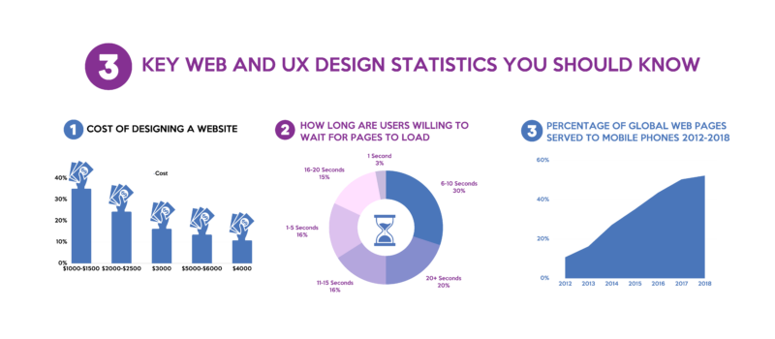

[Source](https://financesonline.com/uploads/2019/10/web-ux-design-statistics-1024x1024.png)

Outsourcing web development is one way to obtain a high-quality website. Like any other new branch of business, there are pros and cons to outsourcing. This raises the question of how much it costs to outsource website development.

## **Why Should You Outsource to a Web Developer?**

Outsourcing web development happens for many reasons. Compatibility, training, resources, the development process, and multiple other factors go into the choice to reach out to a web design firm.

While you sort through the potential reasons for your own partnership to outsource web development, here are some benefits to consider.

### **Saving time**

In business, time = money. This is well-known in all industries. Saving time spent on web development and management lets you focus on more big-picture processes of running your company. A few ways you save time by outsourcing web development include time spent:

* Hiring
* Training
* Organizing schedules
* Setting up pay and benefits
* Performance reviews
* Staff meetings

Instead of working with an in-house team, you work one on one with your web developer to find the right fit for your website.

### **Reduced errors**

Making mistakes is human. Making a mistake on your own website is costly. This mistake is seen by all. In some instances, it might even impact brand reputation and sales. Outsourcing to a professional web developer ensures fewer mistakes are made.

### **Access to expertise**

Unless you went to a school for web developers, chances are this isn’t your area of expertise. When you outsource web development, you put a massively visible part of your business in the hands of an expert.

A web design firm works with the best and brightest in web development and design. You can count on your site to feature the latest in colors, widgets, navigation, and more.

### **Fewer Training Requirements**

Training a web development team as a business owner sounds daunting at best. Unless your business is a web development agency, this is an extremely niche area of ability best left to the experts.

Before you even begin training, your company is tasked with:

* Creating training framework for web developers
* Hiring and training trainer or project manager for your in-house team
* Scheduling training classes
* Determining if training is paid or unpaid

There are a lot of moving parts and only so many hours in a day. Outsourcing web development lets you clean your hands of this process. Your web design agency will handle all the training and ensure consistency is seen throughout your site.

### **Compliance Awareness**

There’s a lot to know about designing a website. Not only in terms of aesthetics, but in legal and navigational aspects as well. Compliance with search engine algorithms and the government is important to the success of your website.

Web development professionals know about all the red tape within this industry and how to avoid it. Stick within compliance laws and keep Google happy by ensuring your site is maintained by an experienced website designer.

## **What Impacts the Cost of Outsourcing Web Development?**

Website design outsourcing differs from sales or customer service outsourcing. This is really more of a one-time (until you need to upgrade) service. So, rather than paying by the month, or for an annual package, you’re likely to pay by the hour.

Outsourcing web development fluctuates in cost based on a variety of factors. Here are some of the elements that might impact your web development cost.

### **Accessibility**

Accessibility is a major issue for website owners these days. Modern consumers want to quickly and efficiently access the information they’re looking for. This includes information on your business, products, and services.

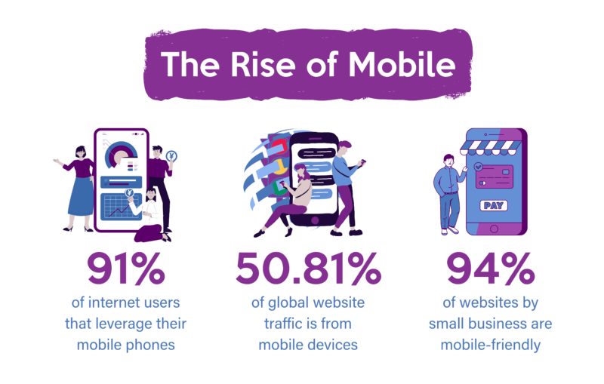

[Source](https://financesonline.com/uploads/2021/01/The-rise-of-mobile.jpg)

Many of your customers, whether you’re a B2C business or a B2B business, will browse from a mobile device. Mobile-friendly websites are more common these days, but not every company has one. Investing in this level of accessibility may cost extra when you outsource web development, but it’s worth it.

### **Special services**

Web design agencies usually provide web development and maintenance as standing services. However, you can find design professionals that offer add-on services or design elements to your website. For example:

* Custom videos
* Image hosting
* Form templates
* Animation
* E-commerce website options
* Content management system

Anytime you require a higher level of customization or additional features, you run the risk of paying extra to outsource web development.

### **Skill**

Website developers come in varying skill levels. A junior developer, for example, will cost less to hire than a middle-level or senior developer. Similarly, an architect developer will cost more.

You’ll also pay for skill level in terms of the software, code language, and design libraries used. Successful web development projects may require more than one skill level.

### **Location**

Where your web development partner resides could impact the cost. From time zone to language barriers, you’ll likely pay more for a North American web developer than an international one.

### **Availability**

When your web development team is available to you is integral to the success of the project. The web development cost increases with availability. Teams that work from 9 to 5 Monday to Friday are going to be less expensive than a tech team available 24/7.

### **Contract type**

As we mentioned above, web development alone is a one-time cost (until you upgrade). However, you can increase your web development cost by choosing a long-term contract covering ongoing website maintenance.

Algorithms and compliance laws are constantly shifting. Having a team on-call to follow these updates keeps your site active and legal.

## **Average Costs to Outsource Website Development**

Outsourcing your website development needs is a money saver. Rather than paying an annual salary for an in-house design team, you’ll pay roughly $150 an hour.

This is based on a web designer in the United States. Web development cost drop as you leave North America. In European countries, for example, you may only pay around $80 an hour for a web designer.

This web development cost can also change depending on the size of your website. In this way, big businesses with many employees and customers, with pages and pages of products and services will pay more.

1. Small businesses: With small websites containing minimal navigation can get a site up and running for between $500 and $1,000.
2. Mid-sized companies: Slightly larger companies requiring websites with more bells and whistles could see the price increase from $1,000 to $5,000.
3. Large corporations: For a large company with multiple pages, special tools, extra features, and a project manager, you could pay as much as $20,000 to $30,000 for a website.

You’ll need to consult your budget and marketing team to determine the size and style of site you need, before asking, how much does it cost?

## **Outsourcing Web Development vs. In-House Website Development – Direct Comparison**

According to [Glassdoor](https://www.glassdoor.com/Salaries/us-website-designer-salary-SRCH_IL.0,2_IN1_KO3,19.htm), a web designer earns roughly $56,687 a year. You might pay more or less based on an employee’s experience and education. Comparing this with the total cost of a website development task, it seems a hefty price to pay.

There’s more than salary alone to consider as you compare in-house website development with outsourcing the task. Here are some comparisons for thought.

### **Initial setup costs**

Starting a contract with an outsourced web developer is as simple as offering a downpayment, registration fee, or making the first payment in an organized payment plan. Some may have no initial fees and simply ask for payment in full.

An in-house web development team, on the other hand, has some startup costs to think about, such as:

* Specialized software: Web development software is quite a niche. It all depends on the brand you choose. This could run between $500 and $10,000.
* Equipment: Equipment like computers and phones are important to this role. Factor around $1,000 to $5,000.
* Furniture: Furnishings such as desks, chairs, lighting, etc, are all needed for a new department. Prices fluctuate, but you could spend roughly $1,000 to $5,000 for a small staff.
* Office space: Leasing an office is by the square foot. Depending on office size, you might need to add an extra $25,000 to your current commercial space budget.
* Salary and benefits: As mentioned above, you could pay around $56,687 for a new web development employee.
* HR time for acquiring new talent: HR costs roughly $26 to $33 an hour for vetting, interviewing, and onboarding a new web development employee.

Doing this math certainly makes outsourcing web development appear cheaper. However, if you have a large company with ongoing web development needs (security, IT, etc.), you could require a full-time design staff and make it worthwhile.

### **Ongoing expenses**

Like the initial fees you’ll pay to a startup, there are ongoing expenses to consider for web development. These are any costs that continue throughout the life of your company. For an in-house web design team, you’ll likely pay for:

* Equipment upkeep: This could be around 5% of the cost to replace your equipment each year.
* Ongoing training: Training never ends for tech-related fields. The internet is constantly evolving and your staff needs to evolve with it.
* Software upgrades: As web design trends change, software updates. Sometimes you’ll need to buy new software.

If you have a large web design team you might want to think about a project manager. This is another ongoing cost as it results in another salary and benefits.

### **Total cost of ownership**

Adding all these costs up is tough at a glance. But as a rough estimate for jumping off, you can expect to pay about $89,678 for one in-house designer, equipment, office space, etc. Tack on another $56,687 for each additional staff member.

## **Choosing the Right Website Development Provider**

Cost is only one part of selecting a website development partner. This is a professional who will essentially build the digital representation of your brand. It’s a huge responsibility and one you want to reflect your company’s voice and culture.

On this note, we recommend working with an experienced outsourcing partner like [The New Workforce](https://thenewworkforce.com/). The New Workforce offers a refined selection of BPOs including website development, sales, IT, customer service, and more. Each employee is selected for their skill and dedication to their trade.

Keeping this in mind, here are some of the factors to consider as you look for the right web designer for you.

### **Reputation and experience**

This is massive. Reputation is something your website will impact your brand. Choosing a company with a good reputation reflects well on what they can do for your company in this regard.

Experience plays a big role in reputation because it teaches companies how to handle themselves in different situations. Problem-solving, specialized expertise, and use of tools and software, all come down to experience.

### **Quality of service**

Websites do a lot for companies across a wide range of industries. High-quality work is crucial to the success of your website.

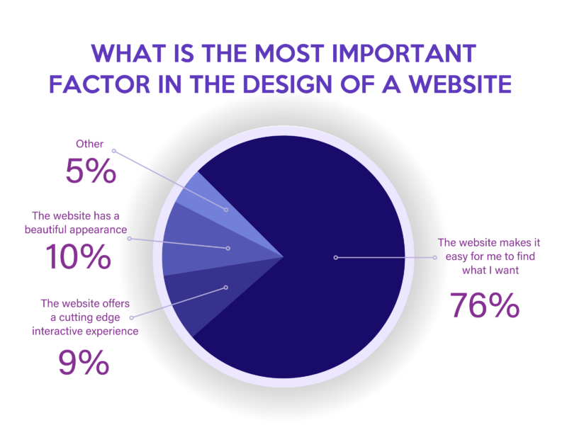

[Source](https://s.financesonline.com/uploads/2021/01/The-rise-of-mobile-768x602.jpg)

Pay close attention to areas like:

* Loading times
* Ease of navigation
* Accessibility (mobile-friendly or not)

Don’t be afraid to ask for examples of past work, or a custom sample page, to see what a designer can do for you.

### **Integration with existing systems**

Not every web design tool works with every hosting service or design platform. You want to choose an outsourced website development company that can work with what you’ve chosen as a host, platform, or software.

Most web developers list the types of technology and coding they are familiar with. An outsourced project shouldn’t force you to change your operating system.

### **Customer support**

You’re the customer in situations where you purchase the services of web design firms. As the customer you’re entitled to support throughout the build, but also ongoing should something go wrong with your site.

Look at things like:

* Availability
* Language
* Time zone
* Number of employees on call

Anything that simplifies the customer service process and ensures your website is always running smoothly.

## **In Closing**

Throughout this guide to outsourcing web development, we touched on several subjects, including:

* The benefits of outsourcing: Fewer errors, time saved, reduced cost, less training.
* The costs of outsourcing web development vs. in-house web development: Salary, training, equipment, upgrades, office space.
* What to look for in a web designer: Experience, reputation, compatible technology, and good customer service.

Hopefully, you’ve found some useful information and tips on finding the best outsourcing partner for your brand. And received a roundabout answer to the question, how much does it cost to outsource web design?

Whether you go in-house or outsource is totally personal and depends on your budget and business size.